TITLE OF PROJECT

Titanic Survival Prediction Using Machine Learning

21O-CSR-340_19CBS-1_A

MINOR PROJECT -II

A Project Work Synopsis

BACHELOR OF ENGINEERING

IN
COMPUTER SCIENCE AND BUSINESS SYSTEM-CS211

Submitted by:

STUDENTS DETAILS
Name | UID
NAVYA ARORA | 19CBS1027
LAKSHAY LAMBA | 19CBS1035
CHANDRA SHEKHAR KUMAR | 19CBS1041
SPARSH PHUTELA | 19CBS1016
MD SAQUIB NAZAR | 19CBS1011

Under the Supervision of:
DR RAJEEV KUMAR

SUPERVISORS NAME
DR RAJEEV KUMAR

DR RAJEEV

CHANDIGARH UNIVERSITY, GHARUAN, MOHALI - 140413, PUNJAB


 |  | Table of Contents
 | Title Page |  | i
 | Abstract |  | ii
 | List of Figures |  | iii
 | List of Tables (optional) |  | iv
 | Timeline / Gantt Chart |  | v
 |  |  | v
1. | INTRODUCTION* |  | 1
 | 1.1 | Problem Definition | 1
 | 1.2 | Project Overview/Specifications* (page-1 and 3) | 2
 | 1.3 | Hardware Specification | 3
 | 1.4 | Software Specification | 4
 |  | 1.3.1 | 4
 |  | 1.3.2
 |  | …
2. | LITERATURE SURVEY |  | 5
 | 2.1 | Existing System | 5
 | 2.2 | Proposed System | 6
 |  |  | 7
3. PROBLEM FORMULATION
4. | RESEARCH OBJECTIVES |  | 40
5. | METHODOLOGY |  | 47

- TENTATIVE CHAPTER PLAN FOR THE PROPOSED WORK

- REFERENCES

- APPENDICES
1 INTRODUCTION
We will be understanding, how to analyze and predict, whether a person, who had boarded the RMS Titanic has a chance of survival or not, using Machine Learning’s Logistic Regression model.

Brief description about Logistic Regression:
A simple yet crisp description of Logistic Description would be, “it is a supervised learning classification algorithm used to predict the probability of a target variable. The nature of target or dependent variable is dichotomous, which means there would be only two possible classes
The graph of logistic regression is as shown below:
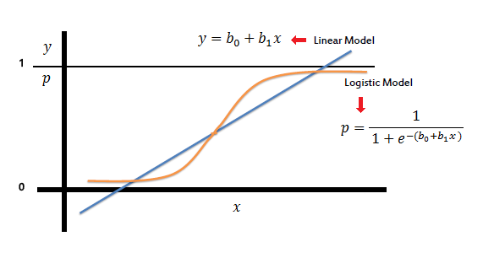
Let’s Dive into the process..!! :
Now let us begin the main part of this article.
If you prefer an audio-visual understanding of this process, you can refer to this video below. It goes through everything in this article with a little more detail and will help make it easy for you to start programming your own machine-learning model, even if you don’t have python installed on your computer.
Or you can use both as supplementary materials for learning about machine learning!
For better understanding, let’s split the task into smaller parts and depict them in a workflow as shown below :
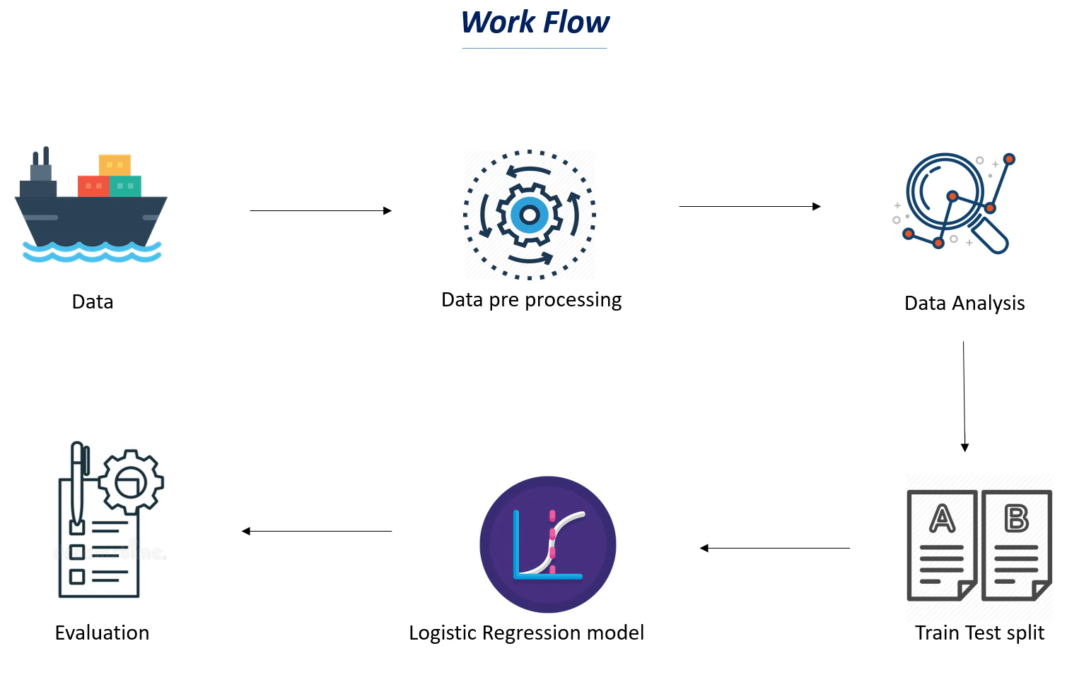
As we now know what we have to do, to accomplish this task, we shall begin with the very first and the most important thing needed in machine learning, a Dataset.

What is a dataset:
A data set, as the name suggests, is a collection of data. In Machine Learning projects, we need a training data set. It is the actual data set used to train the model for performing various actions.
Here, in this case, we will be using a dataset available on the internet. One can find various such datasets over the internet.
The dataset that I’ve used in my code was the data available on Kaggle. You can also download it from here.
One thing must be kept in mind, the larger the data, the more we can train our model, and the more accurate our results come out to be. Don’t worry if all of this sounds weird to you, it will all make sense in a few minutes.

2 LITERATURE REVIEW

MACHINE LEARNING AND ARTIFICIAL INTELLIGENCE.
- Artificial Intelligence/Machine learning does not only mean robots or Sci-Fi movies!
- Machine learning applications are everywhere!
- Google search engine, amazon recommender systems, Facebook facial recognition (tagging), Siri.

MACHINE LEARNING AND ARTIFICIAL INTELLIGENCE: PROCESS
Machine learning is the study of algorithms that teach computers to learn from experience.
Through experience (more training data), computers can continuously improve their performance.

MACHINE LEARNING: SUPERVISED LEARNING
- Supervised: used to train algorithms using labeled input and output data.
- Performance is assessed by comparing trained model prediction vs. real output.

LOGISTIC REGRESSION CLASSIFICATION
Logistic regression is a supervised learning classification algorithm used to predict the probability of a target variable. ... It is one of the simplest ML algorithms that can be used for various classification problems such as spam detection, Diabetes prediction, cancer detection etc.

.

One must know to complete the project successfully.
- Use of the python language .
- some facts and base of machine learning.
- Application/software used for the project .
- Information about Some library files used in the project.
- Reading the graphs.
- Strong grip of reading the code as well as feeding the code .
2.1 Literature Review Summary

Table 2.1: Literature review summary

Year and | Article Title | Purpose of the | Tools/ | Comparison | Source | Findings | Data set (if used) | Evaluation
citation | Article Title | Purpose of the | Software | of technique | (Journal/ | Findings | Data set (if used) | Evaluation
citation | Article Title | study | Software | of technique | (Journal/ |  |  | parameters
 |  | study | Used | done | Conference) |  |  | parameters
2010

3. PROBLEM FORMULATION
➔ Compile time errors may occur.
➔ Not choosing a right tool.
➔ Problem may arise during installation of latest version of pycharm and importing libraries and files (like pygame, Mixer, Math).
➔ Syntax errors and Run time errors may occur.
➔ -->Problem may arise during Debugging.
➔ -->Problem may arise during the back ground setting by loading proper .PNG extension image.

4 CHAPTER 4: METHODOLOGY

SOME TECHNICAL WORK INFORMATION IS AS FOLLOWS-
- Use of the ANACONDA PLATFORM which is the fastest platform for running python language as well as contains all the packages which is to be used in machine learning.
.
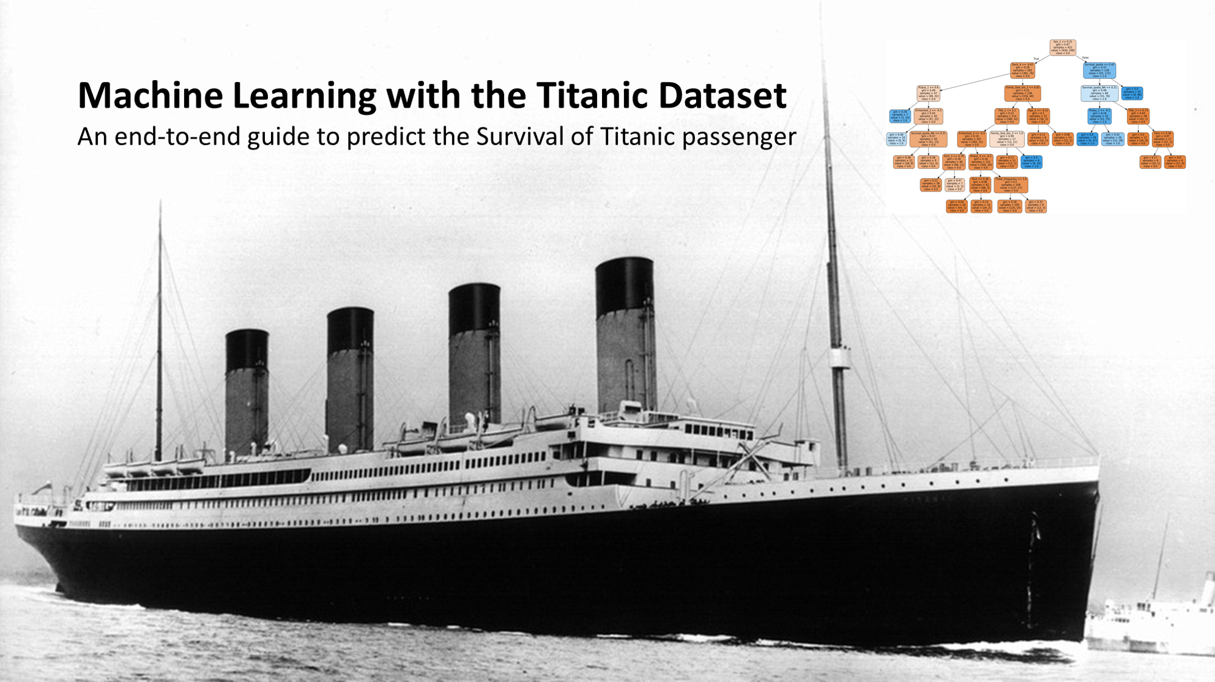

The following methodology will be followed to achieve the objectives defined for proposed research work-
- Jupyter notebook is the open source web application use to document the text as well as write the code. Moreover, we can write our own text ,upload images of it .
- Use of the logistic regression algorithm.it is used to predict the output of the two classes .example- fail/pass, win/loss.
- Use of the linear regression instead of the linear equation.linear equation is basically an equation of two variables which gives a straight line wheras regression is the prediction of output on a continuous spectrum.

- Use of sigmoid function which is equal to 1/1+e ^ -(b1+b2x).it basically gives the probability .

- Use of threshold values to predict the situation. Hence, this is suited for classification model.

- Importing library files such as pandas for plotting ,loading the datasets to database, numpy for numeric analysis and seaborn for data visualization and much more .

- Representation of data in form of confusion matrix .

- sckit learn tool for prediction of data analysis used in training and testing the model.

- Concept of feature engineering.

6. TENTATIVE CHAPTER PLAN FOR THE PROPOSED WORK
Titanic Survival Prediction Using Machine Learning
This project is to replicate the core a machine learning project based. We will be using logistic regression in this project. Basically, the prediction would play a major role in it. We would be learning some library files and much more. We will be understanding, how to analyse and predict, whether a person, who had boarded the RMS Titanic has a chance of survival or not, using Machine Learning’s Logistic Regression model.
Hey folks, in this article, we will be understanding, how to analyse and predict, whether a person, who had boarded the RMS Titanic has a chance of survival or not, using Machine Learning’s Logistic Regression mode.

The project name is Titanic Survival Prediction Using Machine Learning. which is very interesting. AS nowadays many of the machine learning is more popular . In this project I will go through the whole process of creating a machine learning model on the dataset provide .this provides information on the fate of passengers through dataset, summarized according to economic status (class), sex, age and survival. So,

Firstly, for that we have surfed on the internet and some books. for this we needed to learn the language named python not in so much deep but some of the basic stuff which includes the syntax as well as loop the most important.so for that we watch some of the videos on the youtube for it and also study some books for practice. It took approximately week depends upon our capable.

CONCLUSION AND FUTURE SCOPE

Conclusion
Congratulations on what you've accomplished here! You should now have an algorithm for predicting whether or not a person survived the Titanic disaster, based on their features.


- Understand theory behind logistic regression
- Apply sigmoid function to obtains probability
- Lod data set from a CSV file using panda data frame
- Develop function in python and apply it panda frame work
- Plots several plots using seaborn library such as plots, histograms, ,heat maps
- Fill out missing data points (null elements)
- Convert category →dummy variables
- Divide data set into training & testing using scikit-learn
- Train logistic classification model using scikit learn
10. Evaluate model & present result using classification reports

DECLARATION
We, ‘Navya Arora(19CBS1027), Chandra Shekhar(19CBS1041), Lakshay Lamba(19CBS1035), Sparsh Phutela(19CBS1016) and M Saquib Nazar(19CBS1011), student of ‘Bachelor of Engineering in Computer Science and Business System’, session:2020-2021, Department of Computer Science and Engineering, Apex Institute of Technology, Chandigarh University, Punjab, hereby declare that the work presented in this Project Work entitled ‘Titanic Survival Prediction Using Machine Learning’ is the outcome of our own bona fide work and is correct to the best of our knowledge and this work has been undertaken taking care of Engineering Ethics. It contains no material previously published or written by another person nor material which has been accepted for the award of any other degree or diploma of the university or other institute of higher learning, except where due acknowledgment has been made in the text. Navya Arora (19CBS1027) Chandra Shekhar (19CBS1041) Lakshay Lamba (19CBS1035) Sparsh Phutela (19CBS1016) and Saquib Nazar (19CBS1011)

Date: 16 September, 2021

ACKNOWLEDGEMENT
WE have taken efforts in this project. However, it would not have been possible without the kind support and help of many individuals and organizations. I would like to extend my sincere thanks to all of them. I am highly indebted to PROFESSOR RAJEEV KUMAR SR for their guidance and constant supervision as well as for providing necessary information regarding the project & also for their support in completing the project. I would like to express my gratitude towards my teammates and my department for their kind co-operation and encouragement which help me in completion of this project. THANKS AGAIN TO ALL WHO HELPED

ABSTRACT
Our goal for this project is to replicate the core a machine learning project based. We will be using logistic regression in this project. Basically, the prediction would play a major role in it. We would be learning some library files and much more. We will be understanding, how to analyse and predict, whether a person, who had boarded the RMS Titanic has a chance of survival or not, using Machine Learning’s Logistic Regression model.
Hey folks, in this article, we will be understanding, how to analyse and predict, whether a person, who had boarded the RMS Titanic has a chance of survival or not, using Machine Learning’s Logistic Regression mode.
A simple yet crisp description of Logistic Description would be, “it is a supervised learning classification algorithm used to predict the probability of a target variable. The nature of target or dependent variable is dichotomous, which means there would be only two possible classes.” as stated in the tutorial points .

7.References
➢You tube
➢Books:
➢ GeeksforGeeks for python language, https://www.programiz.com/python-programming
- J. F. Islam, M. Mondal, and C. K. Roy, “Bug Replication in Code Clones: An Empirical Study,” in 2016 IEEE 23rd International Conference on Software Analysis, Evolution, and Reengineering (SANER), 2016, pp. 68–78.

- C. K. Roy, M. F. Zibran, and R. Koschke, “The vision of software clone management: Past, present, and future (Keynote paper),” in 2014 Software Evolution Week - IEEE Conference on Software Maintenance, Reengineering, and Reverse Engineering (CSMR-WCRE), 2014, pp. 18–33.

